This assignment will help you to consolidate the concepts learnt in the session.

2. Problem Statement

Go through below blog and reiterate the same at your end.

https://docs.google.com/document/d/1csLBlMiEXs_hXWV2Z8VpBlrj_R6RoDQLlZUnA0uBT

Ck/edit

1. Find out the state wise population and order by state

*val census_data = sc.textFile("file:///home/cloudera/census.csv").map(x => x.split(",")).map(x => (x(0),x(2),x(3),x(4),x(5),x(6),x(7),x(8),x(9),x(10),x(11),x(12),x(13),x(14),x(15),x(16),x(17),x(18),x(19),x(20),x(21),x(22))).toDF("State" ,"Persons","Males" ,"Females" ,"Growth_1991_2001" ,"Rural" ,"Urban" ,"Scheduled_Caste_population" ,"Percentage_SC_to_total" ,"Number_of_households" ,"Household_size_per_household" ,"Sex_ratio_females_per_1000_males " ,"Sex_ratio_0_6_years" ,"Scheduled_Tribe_population" ,"Percentage_to_total_population_ST" ,"Persons_literate" ,"Males_Literate" ,"Females_Literate" ,"Persons_literacy_rate" ,"Males_Literatacy_Rate" ,"Females_Literacy_Rate" ,"Total_Educated").registerTempTable("census")*

*val population = sqlContext.sql("select state,sum(persons) as total_population from census group by state order by total_population desc").show*

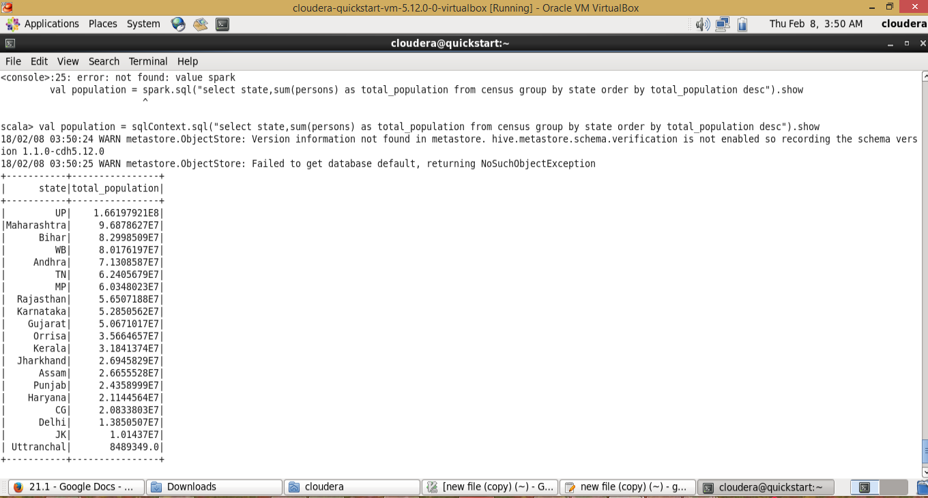

2. Find out the Growth Rate of Each State Between 1991-2001

*val census_data = sc.textFile("file:///home/cloudera/census.csv").map(x => x.split(",")).map(x => (x(0),x(2),x(3),x(4),x(5),x(6),x(7),x(8),x(9),x(10),x(11),x(12),x(13),x(14),x(15),x(16),x(17),x(18),x(19),x(20),x(21),x(22))).toDF("State" ,"Persons","Males" ,"Females" ,"Growth_1991_2001" ,"Rural" ,"Urban" ,"Scheduled_Caste_population" ,"Percentage_SC_to_total" ,"Number_of_households" ,"Household_size_per_household" ,"Sex_ratio_females_per_1000_males " ,"Sex_ratio_0_6_years" ,"Scheduled_Tribe_population" ,"Percentage_to_total_population_ST" ,"Persons_literate" ,"Males_Literate" ,"Females_Literate" ,"Persons_literacy_rate" ,"Males_Literatacy_Rate" ,"Females_Literacy_Rate" ,"Total_Educated").registerTempTable("census")*

*val growth_rate = sqlContext.sql("select state,avg(Growth_1991_2001) as total_growth from census group by state").show*

